3. Installation of operating System (Windows)

**Booting to the Windows 10 Installer**

**1**

**Make sure your Windows 10 installation media is connected.** In order for you to install Windows 10, your Windows 10 installation file must be loaded onto a disc or flash drive, and the disc or flash drive must be inserted into your computer.

If you haven't yet downloaded the Windows 10 installation tool, follow the instructions from this Microsoft support page: <https://www.microsoft.com/en-us/software-download/windows10>

**2**

**Open the Start menu.** Either click the Windows icon in the bottom-left corner of the screen, or press the ⊞ Win key.

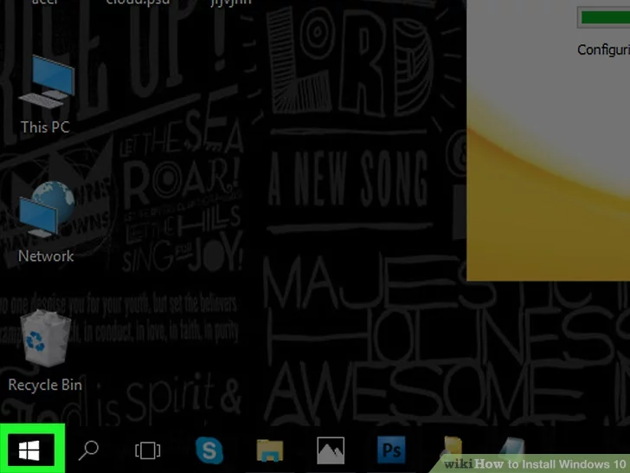

**3**

**Click the power icon.** This is the circle with a line through its top that's in the bottom-left corner of the Start window.

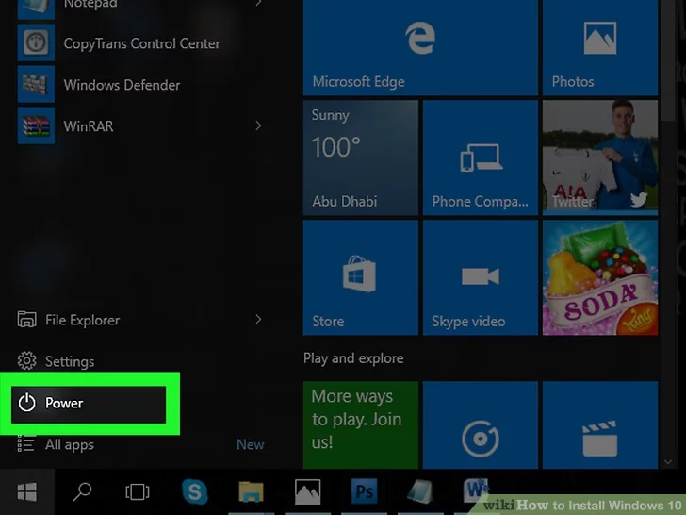

**4**

**Click Restart.** It's in the pop-up menu above the power icon. Doing so will restart your computer.

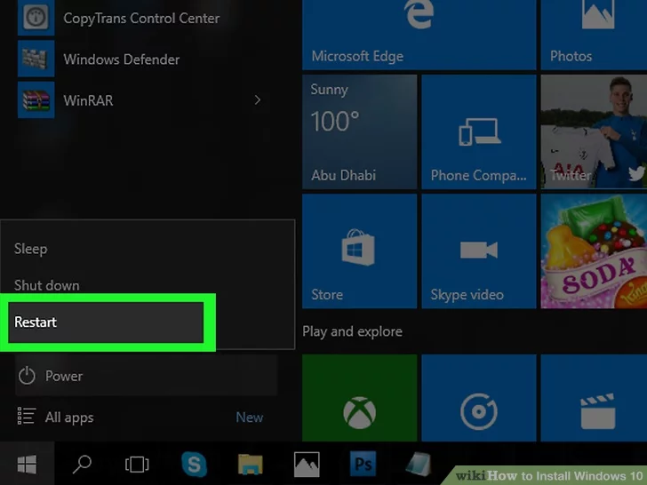

**5**

**Press and hold Del or F2 to enter setup.** This key may also be a different key—most computers will display a message on startup that says "Press [key] to enter setup" or something similar, so look for this message when your computer restarts to confirm the key you should press to access the BIOS.

**6**

**Navigate to the Boot tab.** You'll use the arrow keys to select it.

* + The **Boot** tab may instead say **Boot Options**, depending on your computer's manufacturer.

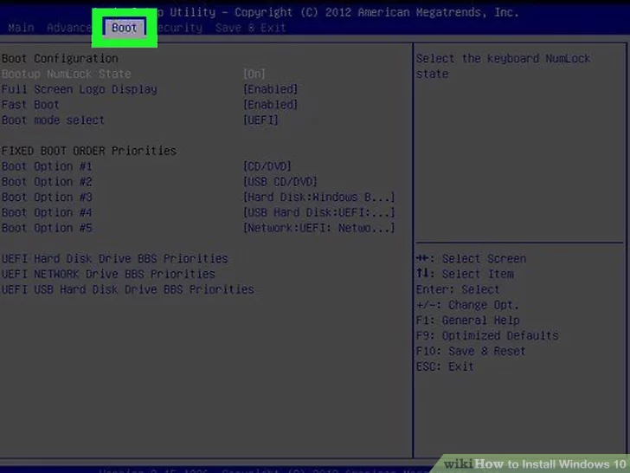

**7**

**Select a device from which to boot.** You have a couple of options here:

* + For a **USB flash drive**, select the **Removable Devices** option.
  + For a **disc installation**, select the **CD-ROM Drive** option.

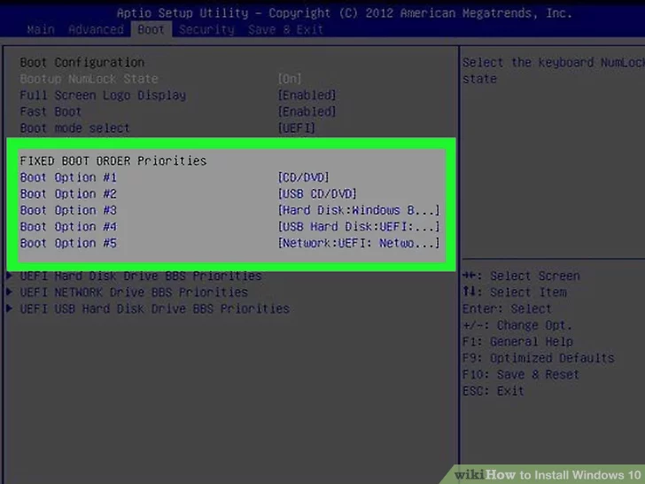

**8**

**Press the + key until your boot option is first.** Once either **Removable Devices** or **CD-ROM Drive** is at the top of the list, your computer will select your choice as its default boot option.

* On some computers, you'll instead press one of the function keys (e.g., F5) to navigate an option up to the top of the menu. The key will be listed on the right side of the screen.

**9**

**Save your settings.** You should see a key prompt (e.g., F10) at the bottom of the screen that correlates to "Save and Exit"; pressing it should save your settings and restart your computer.

* You may have to press ↵ Enter to confirm the changes.

**10**

**Wait for your computer to restart.** Once your computer finishes restarting, you'll see a window here with your geographical data. You're now ready to begin setting up your Windows 10 installation.

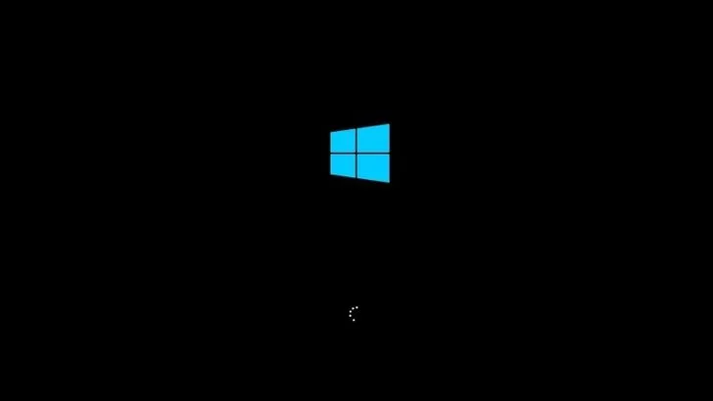

**Part2**

**Installing**

**1**

**Click Next when prompted.** You can also change the options on this page (e.g., the setup language) before continuing if need be.

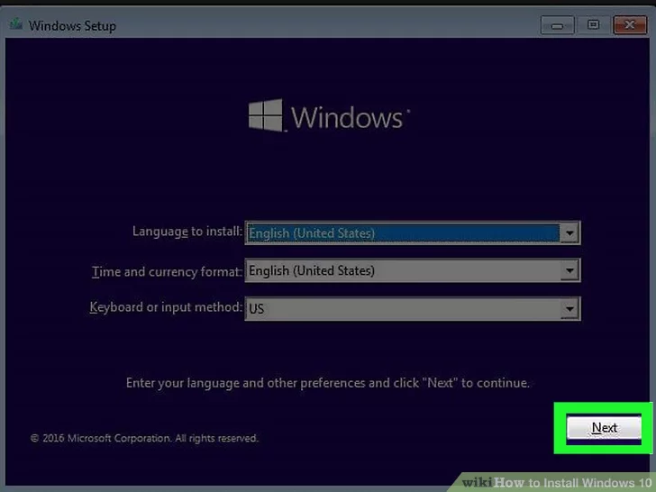

**2**

**Click Install Now.** It's in the middle of the window.

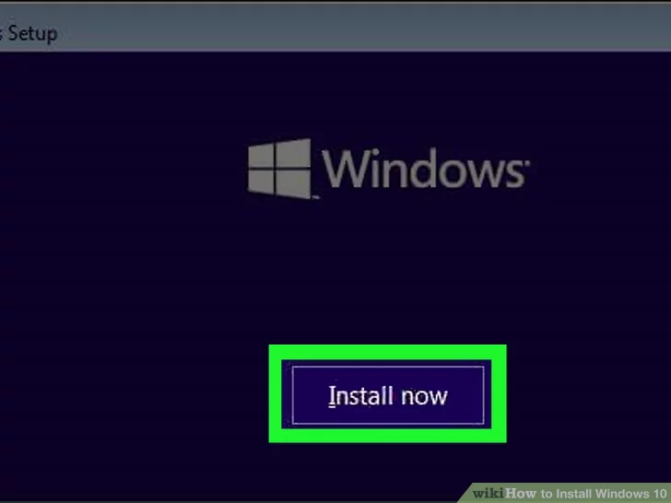

**3**

**Enter your Windows 10 key, then click Next.** If you don't have a Windows 10 key, instead click **Skip** in the bottom-right corner of the screen.

**4**

**Click the "Accept" box and click Next.** This will indicate that you accept the terms of use.

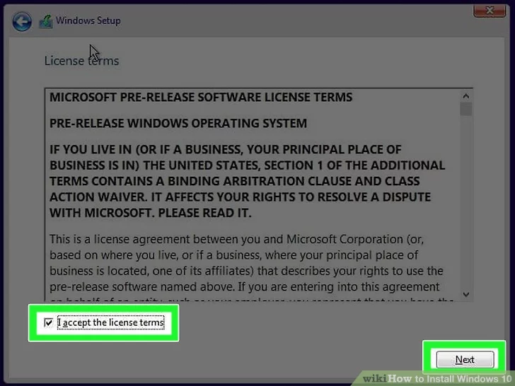

**5**

**Click Upgrade.** It's at the top of the "Which type of installation do you want?" window. This option installs Windows 10 while preserving your files, apps, and settings.

* You can click **Custom** instead to clean install Windows 10 on your computer. Doing so will prompt you to select a partition to format before continuing.

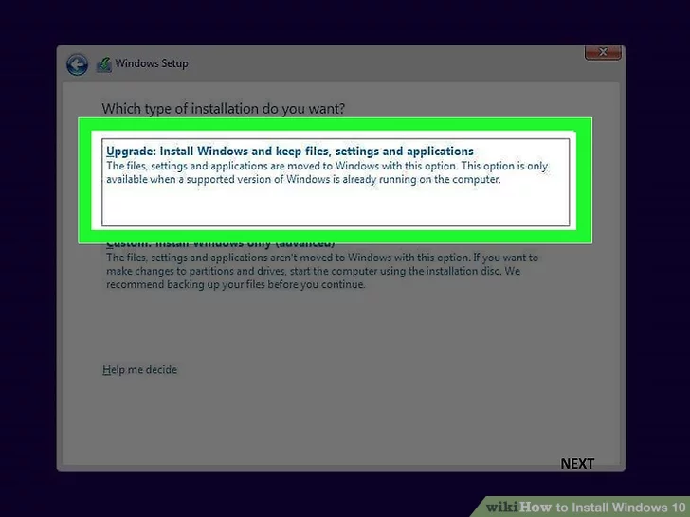

**6**

**Wait for Windows 10 to install.** This process may take anywhere from half an hour to several hours, depending on your computer's previous operating system and processing speed.

* + If prompted to press a key in order to boot from a CD, *do not press a key*.

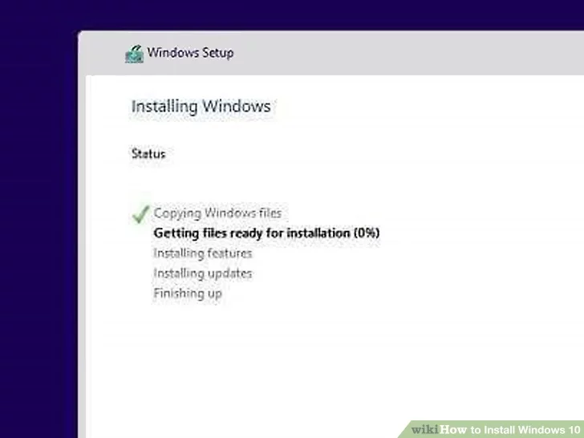

* **7**

**Follow the on-screen setup instructions.** Once Windows 10 has been installed on your computer, you'll be able to customize its settings (e.g., your region, your preferred language, location settings, etc.). Once you finish this process, you will be taken to your computer's desktop.

* + You can also click **Express Settings** to set up Windows 10 with the recommended settings.